VoIP Phone
IP-900B
User Manual

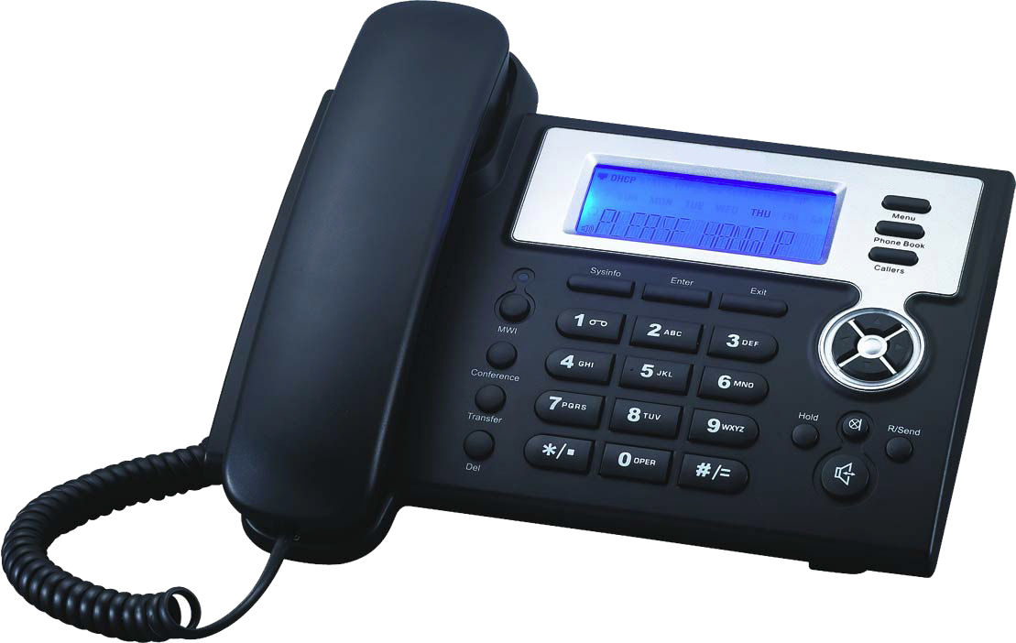

 Safety Notices

Please read the following safety notices before installing or using this phone. They are crucial for the safe and reliable operation of the device.

- Please use the external power supply that is included in the package. Other power supplies may cause damage to the phone, affect the behavior or induce noise.

- Before using the external power supply in the package, please check with home power voltage. Inaccurate power voltage may cause fire and damage.

- Please do not damage the power cord. If power cord or plug is impaired, do not use it, it may cause fire or electric shock.

- The plug-socket combination must be accessible at all times because it serves as the main disconnecting device.

- Do not drop, knock or shake it. Rough handling can break internal circuit boards.

- Do not install the device in places where there is direct sunlight. Also do not put the device on carpets or cushions. It may cause fire or breakdown.

- Avoid exposure the phone to high temperature, below 0℃ or high humidity. Avoid wetting the unit with any liquid.

- Do not attempt to open it. Non-expert handling of the device could damage it. Consult your authorized dealer for help, or else it may cause fire, electric shock and breakdown.

- Do not use harsh chemicals, cleaning solvents, or strong detergents to clean it. Wipe it with a soft cloth that has been slightly dampened in a mild soap and water solution.

- When lightning, do not touch power plug or phone line, it may cause an electric shock.

- Do not install this phone in an ill-ventilated place.

- You are in a situation that could cause bodily injury. Before you work on any equipment, be aware of the hazards involved with electrical circuitry and be familiar with standard practices for preventing accidents.

Table of Content

1. Introducing IP-900B VoIP Phone 5
1.1. Thank you for your purchasing IP-900B 5
1.2. Delivery Content 6
1.3. Keypad 6
1.4. Port for connecting 8
2.Initial connecting and Setting 8
2.1. connect the phone 8
2.2. Initial Setting 9
2.2.1. PPPoE mode. 10
2.2.2. Static IP mode: 11
2.2.3. DHCP mode 12
3. Basic Functions 13
3.1. Basic operation 13
3.1.1. Accepting a call 13
3.1.2. Making a call 13
3.1.3. Ending a call 14
3.1.4. Transferring a call 14
3.1.5. Calling Hold and 3 ways call 14
3.1.6. Callers 15
3.2. The high-level operation 15
3.2.1. Special Keys 16
3.2.2. Call pickup 16
3.2.3. join call 16
3.2.4. redial/unredial 16
3.2.5. click to dial 17
4. Setting 17
4.1. Setting methods 17
4.2. Setting via Web Browse 17
4.3. Configuration via WEB 18
4.3.1. BASIC 18
4.3.1.1. Status 18
4.3.1.2. Wizard 18
4.3.1.3. Call Log 20
4.3.1.4. MMI SET 20
4.3.2. Network 21
4.3.2.1. WAN Config 21
4.3.2.2. Qos Config 22
4.3.2.3. Service Port 25
4.3.2.4. SNTP 25
4.3.3. VOIP 26
4.3.3.1. SIP Config 26
4.3.3.2. Stun Config 29
4.3.3.3. DIAL PEER setting 31
4.3.4. Phone 34
4.3.4.1. DSP Config 34
4.3.4.2. Call Service 35
4.3.4.3. Digital Map Configuration 36
4.3.4.4. Phone Book 37
4.3.5. Maintenance 38
4.3.5.1. Auto Provision 38
4.3.5.2. Syslog Config 39
4.3.5.3. Config Setting 40
4.3.5.4. Update 40
4.3.5.5. Account Config 41
4.3.5.6. Reboot 42
4.3.6. Security 42
4.3.6.1. MMI Filter 42
4.3.6.2. Firewall 43
4.3.7. Logout 44
4.4. Settings via phone’s keyboard. 44
4.4.1. How to set via the phone’s keyboard. 44
4.4.2. Phone menu 45
5. Appendix 45
5.1. Specification 45
5.1.1. Device specification 45
5.1.2. Voice Features 46
5.1.3. Network Features 46
5.1.4. Maintenance and Management 46
5.2. Digit-character map table 47

- Introducing IP-900B VoIP Phone

1.1. Thank you for your purchasing IP-900B

Thank you for your purchasing IP-900B, IP-900B is a full-feature telephone that provides voice communication over the same data network that your computer uses. This phone functions not only much like a traditional phone, allowing to place and receive calls, and enjoy other features that traditional phone has, but also it own many data services features which you could not expect from a traditional telephone.

This guide will help you easily use the various features and services available on your phone.

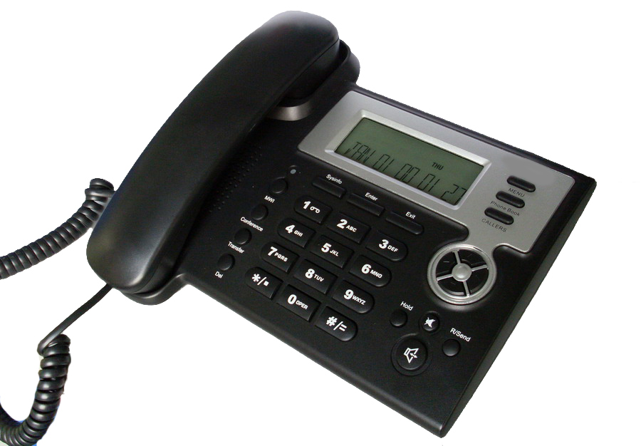

1.2. Delivery Content

Please check whether the delivery contains the following parts:

The base unit with display and keypad

The handset

The handset cable

The power supply

The Ethernet cable

1.3. Keypad

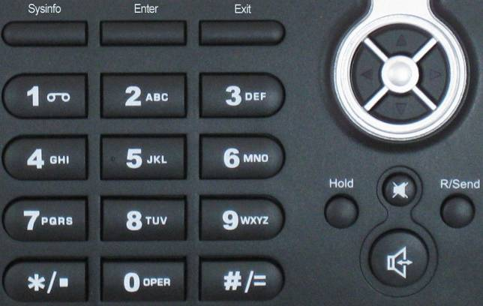

The numeric keypad with the keys 0 to 9, *, and # is used to enter

Digits and letters, additionally, the following keys are available:

Key mapping:

Key | Key name | Function Description
 | Menu | In idle state，press the MENU key to call up the menu.
 | Phone Book | In idle mode, press the Phone Book key to check the record list and add new records and revise the record. Press this key again will return to idle mode.
 | Callers | In idle/pickup/calling mode, press the Callers key to Check the Income/Outgoing/Missed calls records. Press this key again will return to idle mode
 | LED | LED blinks to remind user new voicemail.
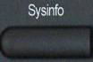 | System Information | In idle mode, press the Sysinfo key to check the phone setting parameters. Such as local phone number, local IP and local Gateway IP address.
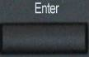 | Confirm | Use the Enter key to enter next menu, or confirm the setting.
 | Exit | Use the Exit key to return to previous menu, ,cancel the setting, or reject to answer a call.
 | Navigation Key | When you pick up the handset or during calling, you can use this key to turn up or turn down the handset volume; when a call comes, you can use this key to adjust ring volume; you also can use this key to choose item in the menu, callers or phone book.
 | MWI | Use this key to read old or new message.
 | Transfer | Use the key to realize blind transfer or attended transfer please refer to 3.1.4.-call transfer for more details).
 | Conference | Use this key to realize the three party call ( pleae refer to3.1.5-Calling Hold and 3 ways call for more details)
 | Delete | In menu, use this key to modify current setting or delete invalid information. And when you input number do call out, you can use it to delete characters
 | Hold | Temporarily hold the active call during the talking; press the key again to unhold the call. You also can press this key then input the third party’s phone number and end with the # key during calling, you can make a call with the third party and hold the previous calling. (3.1.5-Calling Hold and 3 ways call).
 | Mute | Press this key in calling mode, you can hear the other side, and the other side can not hear you
 | R/send | In the hook off /hands-free mode, use the key to dial the last call number; use this key to make a quick dial as soon as you select your desired number in phone book or callers.
 | Handfree | Enter into hands-free mode.

1.4. Port for connecting



POWER | Power switch | Select ON/OFF
DC | Power port | Output: 5V/1.0A
LAN | Network port | Connect it to PC
WAN | Network port | Connect it to Network

The phone has two Network ports: The WAN port and the LAN port. Before you connect the power source, please carefully read Safety Notices of this user manual.

2.Initial connecting and Setting

2.1. connect the phone

Step 1: Connect the IP Phone to the corporate IP telephony network. Before you connect the phone to the network, please check if your network can work normally.

You can do this in one of two ways, depending on how your workspace is set up.

Direct network connection—by this method, you need at least one available Ethernet port in your workspace. Use the Ethernet cable in the package to connect WAN port on the back of your phone to the Ethernet port in your workspace. you can make direct network connect. The following two figures are for your reference.
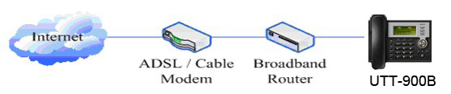



Shared network connection—Use this method if you have a single Ethernet port in your workspace with your desktop computer already connected to it. First, disconnect the Ethernet cable from the computer and attach it to the WAN port on the back of your phone. Next, use the Ethernet cable in the package to connect LAN port on the back of your phone to your desktop computer. Your IP Phone now shares a network connection with your computer. The following figure is for your reference.
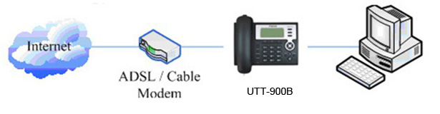

Step 2: Connect the handset to the handset port by the handset cable in the package.

Step 3: connect the power supply plug to the DC port on the back of the phone. Use the power cable to connect the power supply to a standard power outlet in your workspace.

Step 4: push the on/off switch on the back of the phone to the on side, then the phone’s LCD screen displays “WAIT LOGON”. Later, a ready screen typically displays the date, time and current network mode.

If your LCD screen displays different information from the above, you need refer to the next section “Initial setting” to set your network online mode.

If your VoIP phone registers into corporate IP telephony Server, your phone is ready to use.

2.2. Initial Setting

This VoIP Phone provides you with rich function and parameters setting. If you have enough knowledge about network and SIP protocol, it is better for you to understand many parameters. But if you know little about network and SIP protocol, you can also easily make initial setting according to the following steps to enjoy rapidly high quality voice and low cost from this VoIP Phone.

Before make initial setting, please check if your corporate IP telephony network can work normally, and you have finished “connect the phone”.

This VoIP Phone Supports DHCP by default. It will receive an IP address and other network-related settings (Netmask, IP gateway, DNS server) from the DHCP server. If your network supports DHCP, you can connect this VoIP Phone directly to the network. If your network doesn’t support DHCP, you need change this VoIP Phone’s network connection setting. According to the following steps, change this VoIP Phone’s DHCP network connection setting into PPPoE or static IP which your network supports at present.

2.2.1. PPPoE mode.

1. Press the 3 key for three seconds, then confirm it by the Enter key, your phone network connection mode will switch into PPPoE mode. Prepare your PPPoE account name and password.
2. Press the MENU key, the LCD screen will display “INPUT PASSWORD”.
3. Input the password (default value is 123), and press the ENTER key, the LCD screen will display “NETWORK”.
4. Press the key and LCD screen will display “LAN”, press the key, enter it by the key, the LCD screen will display “STATIC NET”. Then press the key again, enter it by the key, the LCD screen will display “USER NAME”.
5. Press the key and then press the key, input your PPPOE account number then press the key to confirm. The LCD screen will display the inputted PPPOE account number.
6. Press the key to return to the previous menu, then press the key, the LCD screen will display “PASSWORD”. Then press the ENTER key, and the DEL key, input your PPPoE’s password and confirm it by the Key, the LCD screen will display the password which you inputted.
7. Press the EXIT key for four times and press the DOWN key, till the LCD screen display “SYSTEM”.
8. Press the ENTER key, the screen display “SAVE”, then press the key again, the LCD screen will display “ARE YOU SURE”.
9. Press the key, the phone will save your setting and the LCD screen will display “SAVING NOW”, then return to display “SAVE”.
10. Press the key twice, then press numeric key “3”and hold until the screen display “ARE YOU SURE”. Press the key, the screen will display “CHANGING”, which means that the phone is trying to switch to PPPoE mode. If the icom “PPPoE” on the top of the screen keeps blink, it shows that the phone is trying to access the PPPoE server., and the IP is still static IP if you press key to display the current IP; if the icon “PPPoE” is showed without blink, it means that the phone has already gotten IP from PPPoE server.

2.2.2. Static IP mode:
1. Press the 1 key for three seconds, then confirm it by the key, your phone network connection mode will switch into Static IP mode. Prepare your phone’s network parameters. They are IP Address of this phone, Subnet Mask, Default Gateway/ Router and DNS. You can ask your VoIP service provider for those parameters.
2. Press the key, the LCD screen will display “INPUT PASSWORD”.
3. Input password (default is 123), then press the key, the LCD screen will display” NETWORK”.
4. Press the key, and the LCD screen will display “LAN”. Press the key, then the key, the LCD screen will display “STATIC NET”.
5. Press the key, the LCD screen will display “IP”. Press the key again and then the key, input your desired IP address for your IP phone and confirmed by pressing the key, then the LCD will display the inputted IP address. When inputting IP with keypad, use “*” instead of “.”.
6. Press the key to return to previous menu, then press the key, the LCD screen will display “DNS2”. Press the key then the key, input your spare DNS address and confirm it by pressing the key, and then the LCD will display the inputted DNS address.
7. Press the key to return to previous menu, then press the key, the LCD screen will display “DNS”. Press the key then the key, input your DNS address and confirm it by pressing the key, and then the LCD will display the inputted DNS address.
8. Press the key to return to the previous menu, and then press the key, the LCD screen will display “GATEWAY”. Press the key again and then the key, input your gateway’s IP address and confirm it by pressing the key, the LCD screen will display the inputted gateway address.
9. Press the key to return to the previous menu, and then press the key, the LCD screen will display “NETMASK”. Press the key again and then the key, input your netmask and press the key to confirm it. The LCD screen will display the inputted netmask.
10. Press the key for four times and press the key, till the LCD Screen displays “SYSTEM”.
11. Press the key, the LCD screen will display “save”, then press the key again, the LCD screen will display” ARE YOU SURE”.
12. Press the key, this phone will display “SAVING NOW”, then return to display “SAVE”.
13. Press the key twice to exit the menu, and then press the numeric key 1 till the LCD screen displays “ARE YOU SURE”. Press the key, the LCD screen will display “CHANGING”. If the icon “static” on the top of screen shows without blink, it means phone has already used the static IP.

2.2.3. DHCP mode

Press the numeric key 2 and hold till the LCD screen displays “ARE YOU SURE”. Press the key, the LCD screen will display “CHANGING” and this VoIP phone is trying to switch to DHCP mode. If the icom “DHCP” on the top of the screen keeps blink, it shows that the phone is trying to access the DHCP server., and the IP is 0.0.0.0 if you press key to display the current IP; if the icon “DHCP” is showed without blink, it means that the phone has already gotten IP from DHCP server.

3. Basic Functions

3.1. Basic operation

3.1.1. Accepting a call

There are four methods to accept an incoming call:
- Pick up handset to accept incoming calls.
- Press the button
- If you need switch from a hands-free call to handset, please pick up the handset directly.
- If you need switch from a handset call to hands-free, please press the button, and then hang up the handset.

3.1.2. Making a call
- Quick-dialing

In idle mode, input the called number, and press # key or button, phone will dial the call and use hands-free automatically.

- Use handset
Pick up the handset, and the LCD screen will display “PLEASE DIAL” and you will hear dialing tone at the same time, then input the phone number and end by the # button. When you hear long ring “du, du…” from handset and the LCD screen display “CALLING”, the call is through. Hang up the handset to end the call.
- Use hands-free
Press the button and the LCD screen will display “PLEASE DIAL” and you will hear dialing tone at the same time, then input the phone number and end by the # button. When you hear long ring “du, du…” and the LCD screen display “CALLING”, the call is through. Press the button again to end the call.
- Use the phone book
Press the button then the button you will enter into the phone book. Press the / button to select your desired contact person, then press the button to dial the call.
- Use Callers
Press the key, then select your desired phone number in callers by the / key, and next press the button to dial the call.

- Use the R/send key
Please pick up or press the key. After you hear dialing tone, please press the key to dial the last phone number. Note: after you reboot the phone, the phone will delete callers and Redial will be invalid.

3.1.3. Ending a call
- Hangs up by handset onhook

- Hangs up by press when in hands-free

- Hangs up a call in call waiting state.
If you are in call waiting state, you could press # key to hang up the current call, and switch to the other call to keep talking.Note: Pressing # key will not hang up if there is only one call currently.

3.1.4. Transferring a call
Call transfer has several ways to realize:
- When A talks to B, B may press the key and dial C phone number. After B talks to C ( or B hear alert from C ), B presses the key, then B hangs up, and A will get through to C.
- When A is talking with B, C calls B, B may press the key to hold A, and talk to C. Then B presses the key, A will get through to C.
- When A talks to B, B presses the key, dial C phone number and # key, then hang up and A will get through to C.

1 and 2 are attended transfer; 3 is blind transfer.
Notice to VoIP Phone Carrier: Your VoIP phone server need support FRC3515, or else transferring can not work.

3.1.5. Calling Hold and 3 ways call

There are two modes to enjoy hold function:
1. Press the key during a call, and the call will be on hold. While a call is on hold, you can establish another call by dialing your desired number and confirm it by the # button. Pressing the key again you will resume the first call. By using hold function, you can talk with only one party; the other party who is on hold can’t talk with you. If you press the * button or key you will enter into 3 ways call.

2. If the third party calls you during a call, the LCD screen will display the incoming call number. Press the key to hold the first call, and then you can talk with the third party. By using hold function, you can talk with only one party; the other party who is on hold can’t talk with you. If you press # key, phone will hang up the first call, and then accept the new incoming call.

Notice: You must enable the calling waiting or else calling hold can’t work.

3.1.6. Callers
The VoIP phone maintains lists of missed, received, and dialed calls. Each list can contain up to 100 entries. If the call list capacity is full, new call will replace the first call. If you stop power supply or restart the phone, the record will disappear.

- Missed Calls
Press the key, and then the /key, till the LCD screen display “MISSED”. Press the key, the LCD screen will display the missed call number and sequence numbersof the missed call.
You can press the key to dial this phone number, you also press UP/DOWN key to browse the other missed calls or you can press the key again, the LCD screen will display the time of the missed calls. If there is no one missed calls, the LCD will display “LIST IS EMPTY”.
- Received Calls
Press the key, and then the /key, till the LCD screen display “RECEIVED”. Press ENTER key, the LCD screen will display the received call number and sequence number of the received call.
You can press the key to dial this phone number, you also press / key to browse the other received calls or you can press the key again, the LCD screen will show the time of the received call. If there is no one received call, the LCD will display “LIST IS EMPTY”.
- Dialed calls
Press the key, and then the / key, till the LCD screen display "OUTGOING".Press key, the LCD screen will display the phone number and sequence number of the dialed call. You can press the key to dial this phone number, or press the / key to browse all record of the dialed calls. If there is on one dialed calls, the LCD will display “LIST IS EMPTY”.

3.2. The high-level operation

This VoIP Phone provides more advanced functions after setting at the permission scope of SIP server.

3.2.1. Special Keys
- Realize Secondary Dial by Dialing for only one time
When you make secondary dial in off-hook/handsfree/standby pre-input mode, press key to postpone input, and screen display will show--. One --stands for 2 seconds. For example, you input 123--45, the phone will send DTMF(45) 2 seconds after the phone call 123. 123------45 will make phone send DTMF(45) at 6 seconds interval.
- MWI(Message Waiting Indication)
When a new voicemail coming, LED on the phone will flash. You can press the MWI key to listen new voicemail if you configure mwi number

3.2.2. Call pickup

Call pickup is implemented by simulating pickup function of PBX. it’s that, when A calls B, B rings but no answer, at this moment, C can hook off and input an appointed prefix plus B’s number, pick up A’s call and talk with A

The following chart shows how to configure an appointed prefix in dial peer to have call pick up function.
*1* means appointed prefix code. After making the above configuration, C can dial *1* plus B’phone number to pick up A’s call. User can set prefix in random, in the case of no affecting current dialing rules.

3.2.3. join call
When B is calling C, A can join in the existing call by inputing an appointed prefix numbers plus B or C number, if B or C also supports join call

The following chart shows how to configure an appointed prefix in dialpeer to have join call function.
*2* means appointed prefix code. After making the above configuration, A can dial *2* plus B or C number to join B and C’s call, . User can set prefix in random, in the case of no affecting current dialing rules.

3.2.4. redial/unredial
If B is in busy line when A calls B, A will get notice: busy, please hang up. If A want to connect B as soon as B is in idle, he can use redial function at the moment and he can dials an appointed prefix number plus B’s number to realize redial function.

What is redial function? A can’t not build a call with B when B is in busy ,then A will subscribe B’s calling mode at 60 second intervals. once B is available, A will get reminder of rings to hook off, while A hooks off, A will call B automatically. If at this time A is occupied temporarily and unwilling to contact B, A also can cancel the redial function by dialing an appointed prefix plus B’s number before making the redial function.
*3* is appointed prefix code. After making the above configuration, A can dial
*3* plus B’phone number to make the redial function.
*4* is appointed prefix code. After configuration, A can dial *4* to cancel redial function.

User can set prefix in random, in the case of no affecting current dialing rules.

3.2.5. click to dial
When user A browses in an appointed Web page, user A can click to call user B via a link (this link to user B), then user A’s phone will ring, after A hooks off, the phone will dial to B.

4. Setting

4.1. Setting methods

VoIP Phone is different from the traditional phone; it need be set to make it active. If your VoIP service provider asks you to set this phone, you can do it easily according to the following methods.
This VoIP Phone can be set via three different setting methods:
The phone key. The initial password is 123 for setting via phone key.
The web browser on PC
Telnet
This Manual will tell you about the setting methods via the web browser on PC.

4.2. Setting via Web Browse

When this phone and your PC are connected to your network, enter the IP address of the wan port in this phone as the URL (e.g. http://xxx.xxx.xxx.xxx/ or http://xxx.xxx.xxx.xxx:xxxx/).
If you do not know the IP address, you can look it up on the phone’s display by pressing the key “SYSINFO”.
After you enter the IP address, you will see the following web interface.
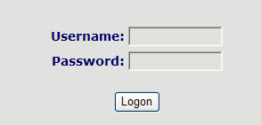

This phone provides different two privileges for different users to set it.
The two privileges are guest and administrator respectively. In guest privilege, user can see but not modify Register/Proxy Sever Addresses and ports of SIP, advance SIP and Iax2. In administrator privilege, user can see and modify all setting parameters.

Default value in guest privilege
Username: guest
Password: guest

Default value in Administrator privilege
Username: admin
Password: admin

Input username and password, click “logon”, and you will enter setting web interface.
There is a selection menu on the left side of the web interface. Click on the desired submenu; the current settings of this submenu will be displayed in the larger field on the right. You can now modify and store the values by using mouse and keyboard of your PC. To save the changes, click on the submenu “maintenance” and then click the “ config” button and the “Save” button on the right field.

4.3. Configuration via WEB

4.3.1. BASIC

4.3.1.1. Status

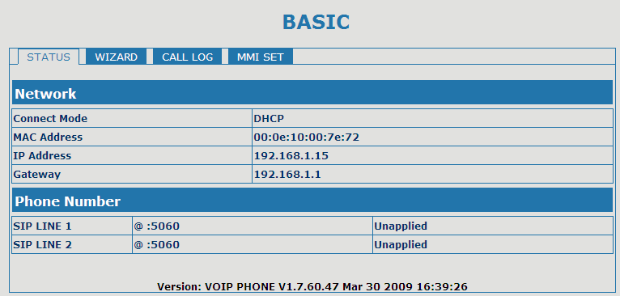Status
Field name | Explanation
Network | Shows the configuration information on WAN and LAN port, including the connect mode of WAN port (Static, DHCP, PPPoE), MAC address, the IP address of WAN port and LAN port, ON or OFF of DHCP mode of LAN port.
Phone Number | Shows the phone numbers provided by the SIP LINE 1-2 servers.  The last line shows the version number and issued date.

4.3.1.2. Wizard

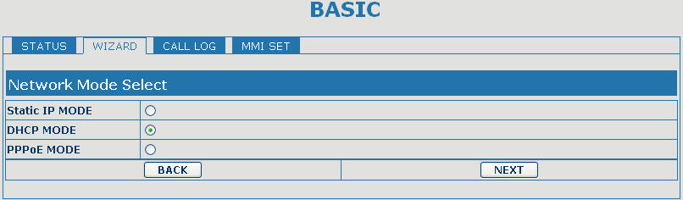

Wizard
Field Name | Explanation
Please select the proper network mode according to the network condition. FV6030 provide three different network settings:
- Static: If your ISP server provides you the static IP address, please select this mode, then finish Static Mode setting. If you don’t know about parameters of Static Mode setting, please ask your ISP for them.
- DHCP: In this mode, you will get the information from the DHCP server automatically; need not to input this information artificially.
- PPPoE: In this mode, your must input your ADSL account and password.
You can also refer to 3.2.1 Network setting to speed setting your network.
Choose Static IP MODE，click【NEXT】can config the network and SIP(default SIP1)easily, also can browse them too. Click【BACK】can return to the last page.
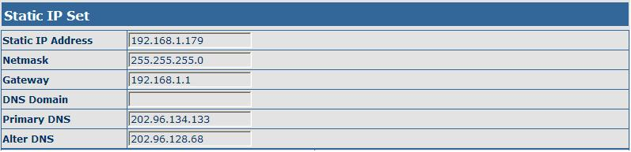
Static IP Address | Input the IP address distributed to you.
Netmask | Input the Netmask distributed to you.
Gateway | Input the Gateway address distributed to you.
DNS Domain | Set DNS domain postfix. When the domain which you inputted can not be parsed, phone will automatically add this domain to the end of the domain which you inputted before and parse it again.
Primary DNS | Input your primary DNS server address.
Alter DNS | Input your standby DNS server address.
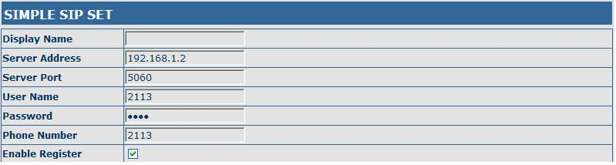
Display Name | If user set the display name, callee will show this display name.
Server Address | Input your SIP server address.
Server Port | Set your SIP server port.
User Name | Input your SIP register account name.
Password | Input your SIP register password.
Phone Number | Input the phone number assigned by your VOIP service provider.
Enable Register | Start to register or not by selecting it or not.
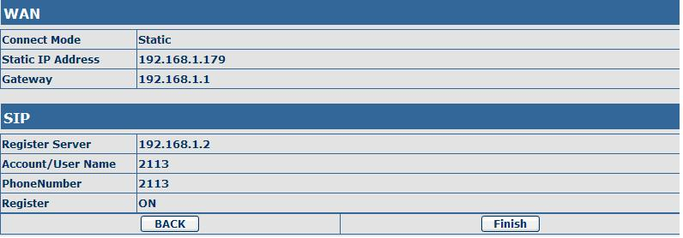
Display detailed information that you manual config.
Choose DHCP MODE，click【NEXT】to config simple SIP(default SIP1). You can browse it too. Click【BACK】to return to the last page. Like Static IP MODE。
Choose PPPoE MODE，click【NEXT】to config the PPPoE account/password and SIP(default SIP1). You can browse it too. Click【BACK】to return to the last page. Like Static IP MODE。
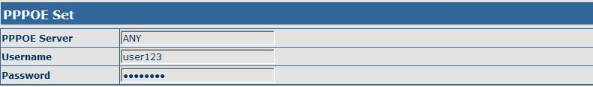
PPPoE Server | It will be provided by ISP.
Username | Input your ADSL account.
Password | Input your ADSL password.
Notice: Click【Finish】button after finish your setting, IP Phone will save the setting automatically and reboot. After reboot, you can dial by the SIP account.

4.3.1.3. Call Log
You can look up all the outgoing calls through this page.

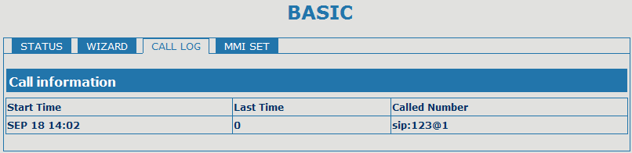
Call Log
Field name | explanation
Start Time | Display the start time of the outgoing call
Last Time | Display the conversation time of the outgoing call.
Called Number | Display the account/protocol/line of the outgoing call.

4.3.1.4. MMI SET

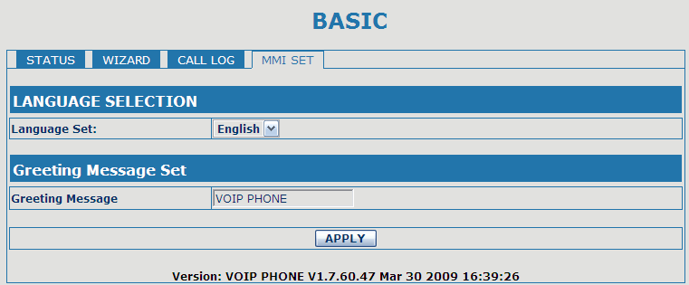
MMI SET
Field name | explanation
Language Set | Set the language of phone, English is default.

4.3.2. Network

4.3.2.1. WAN Config

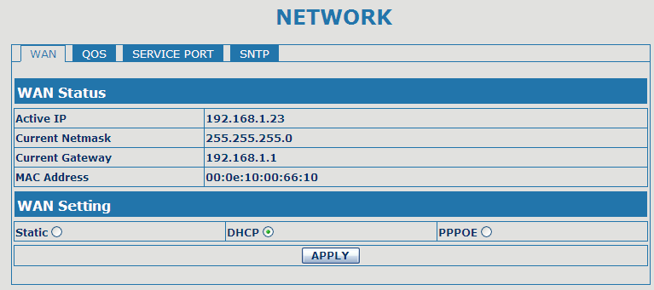

WAN Config
Field Name | explanation
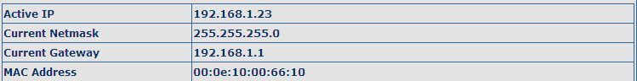
Active IP | The current IP address of the phone.
Current Netmask | The current Netmask address.
MAC Address | The current MAC address of the phone.
Current Gateway | The current Gateway IP address.
Get MAC Time | Shows the time of getting MAC address
Please select the proper network mode according to the network condition. FV6030 provide three different network settings:
- Static: If your ISP server provides you the static IP address, please select this mode, then finish Static Mode setting. If you don’t know about parameters of Static Mode setting, please ask your ISP for them.
- DHCP: In this mode, you will get the information from the DHCP server automatically; need not to input this information artificially.
- PPPoE: In this mode, your must input your ADSL account and password.
You can also refer to 3.2.1 Network setting to speed setting your network.
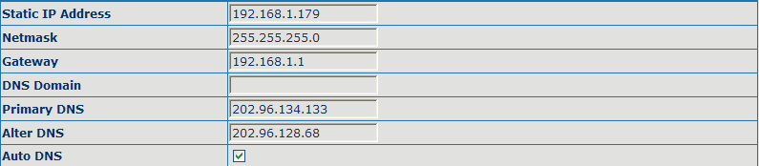
If you use static mode, you need set it.
IP Address | Input the IP address distributed to you.
Netmask | Input the Netmask distributed to you.
Gateway | Input the Gateway address distributed to you.
DNS Domain | Set DNS domain postfix. When the domain which you inputted can not be parsed, phone will automatically add this domain to the end of the domain which you inputted before and parse it again.
Primary DNS | Input your primary DNS server address.
Alter DNS | Input your standby DNS server address.
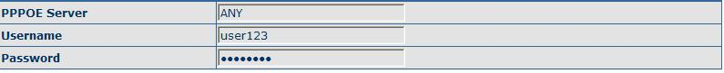
If you uses PPPoE mode， you need to make the above setting.
PPPoE Server | It will be provided by ISP.
Username | Input your ADSL account.
Password | Input your ADSL password.
Notice:
1）Click “Apply” button after finishe your setting, IP Phone will save the setting automatically and new setting will take effect.
2）If you modify IP address, the web will not response by the old IP address. Your need input new IP address in the address column to logon in the phone.
3）If networks ID which is distributed by DHCP server is same as network ID which is used by LAN of system, phone will use the DHCP IP to set WAN, and modify LAN’s networks ID(for example, system will change LAN IP from 192.168.10.1 to 192.168.11.1) when phone uses DHCP client to get IP in startup; if phone uses DHCP client to get IP in running status and network ID is also same as LAN’s, phone will refuse to accept the IP to configure WAN.

4.3.2.2. Qos Config
The VOIP phone support 802.1Q/P protocol and DiffServ configuration. VLAN functionality can use different VLAN IDs by setting signal/voice VLAN and data VLAN. The VLAN application of this phone is very flexible.
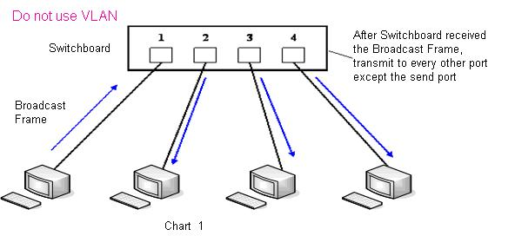
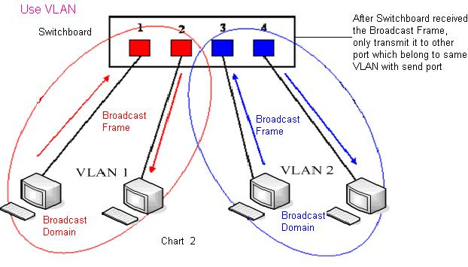
In chart 1, there is a layer 2 switch without setting VLAN. Any broadcast frame will be transmitted to the other ports except the send port. For example, a broadcast information is sent out from port 1 then transmitted to port 2,3and 4.
In chart 2, red and blue indicate two different VLANs in the switch, and port 1 and port 2 belong to red VLAN, port 3 and port 4 belong to blue VLAN. If a broadcast frame is sent out from port 1, switch will transmit it to port 2, the other port in the red VLAN and not transmit it to port3 and port 4 in blue VLAN. By this means, VLAN divide the broadcast domain via restricting the range of broadcast frame transmition.
Note: chart 2 use red and blue to identify the different VLAN, but in practice, VLAN uses different VLAN IDs to identify.
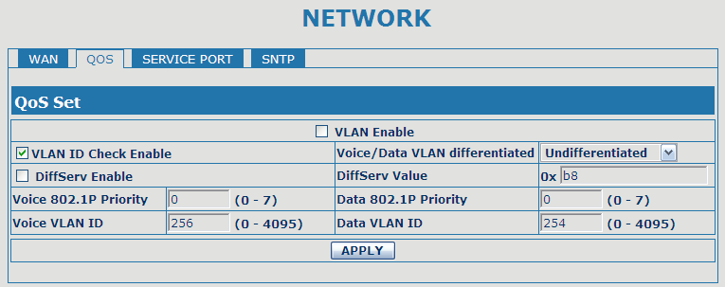

QoS Configuration
Field name | explanation
VLAN Enable | Before select it to enable VLAN, you need enable Bridge mode in LAN config.
VLAN ID Check Enable | Enable VLAN ID check by selecting it. After enable VLAN ID check, if VLAN ID of a data package is not the same with the phone’s or a data package do not have VLAN ID, the data package will be discarded.
Voice/Data VLAN differentiated | After enable VLAN, system will set packets with different type of VLAN ID. Undifferentiated means after using VLAN, both VoIP packets and other data packets will use the voice VLAN ID; tag differentiated means after using VLAN, VoIP(signal and voice) packets will add voice VLAN ID, and other data packets will add data VLAN ID; data untaged means after using VLAN, only VoIP packets will add voice VLAN ID. Other data packets will not use VLAN.
DiffServ Enable | Select it or not to Enable or disable DiffServ.
DiffServ Value | Set DiffServ value, the common value is 0x00.
Voice 802.1P Priority | Specify 802.1P Priority of voice/signal data package.
Data 802.1P Priority | Set 802.1p of data VLAN. Non-VoIP data (such as http, telnet, ping etc) will use this value to set VLAN package.
Voice VLAN ID | Set VLAN ID of voice/signal data package.
Data VLAN ID | Set 802.1q of data VLAN ID. Non-VoIP data (such as http, telnet, ping etc) will use this value to set VLAN package.
NOTICE：
1）Startup VLAN, if set Voice/Data VLAN differentiated as Undifferentiated, all packets will use the Voice VLAN ID as the tag.
2) Startup VLAN, if set Voice/Data VLAN differentiated as tag differentiated and disable the DiffServ, then system will not distinguish the voice and data, all packets will use the Voice VLAN ID as the tag.
3) Startup VLAN, if set Voice/Data VLAN differentiated as tag differentiated and enable the DiffServ, then system will distinguish the voice and data and add the VLAN ID each other.
4) Startup VLAN, if set Voice/Data VLAN differentiated as data untaged, then the packet of the signal/voice will use the Voice VLAN ID as the tag, but the data packets will not take the VLAN tag.
5) If Disable the VLAN, regardless to set the Voice/Data VLAN differentiated or not, all packets will not take the VLAN tag; If enable the DiffServ, all packets will only take the DiffServ value.
6) user need notice, enable the VLAN ID Check Enable that is default, If enable it, the phone will match the VLAN ID strictly. When others' VLAN ID dismatch with us, the packets will discard. Contrarily, the phone will accept the packets with the distinct VLAN ID.
7) You must gain the IP with the Static mode when you set VLAN, otherwise can't gain the IP in the VLAN and also can not dial with point to point.

4.3.2.3. Service Port
You can set the port of telnet/HTTP/RTP by this page.
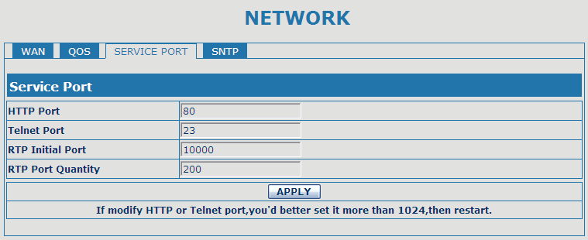

SERVICE PORT
Field name | explanation
HTTP Port | set web browse port, the default is 80 port，if you want to enhance system safety，you'd better change it into non-80 standard port；  Example: The IP address is 192.168.1.70. and the port value is 8090, the accessing address is http://192.168.1.70:8090
Telnet Port | Set Telnet Port, the default is 23. You can change the value into others.  Example:  The IP address is 192.168.1.70. the telnet port value is 8023, the accessing address is telnet 192.168.1.70 8023
RTP Initial Port | Set the RTP Initial Port. It is dynamic allocation.
RTP Port Quantity | Set the maximum quantity of RTP Port, the default is 200.
Notice:
1）You need save the configuration and reboot the phone after set this page.
2）If you modify the port of Telnet and HTTP, you would better set the value more than 1024 because the port value less than 1024 is system port reserved.
3）if you set 0 for the HTTP port, it will disable HTTP service.

4.3.2.4. SNTP
Setting time zone and SNTP (Simple Network Time Protocol) server according to your location, you can also manually adjust date and time in this web page.
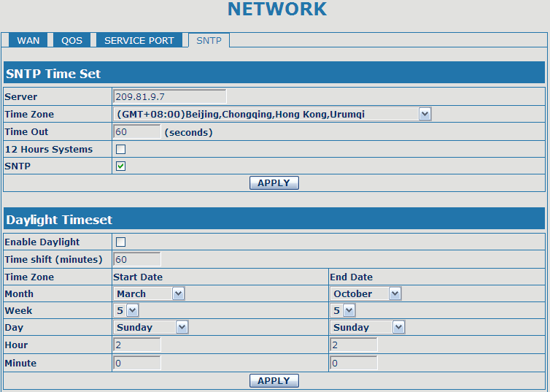

SNTP
Field name | explanation
Server | Set SNTP Server IP address.
Time Zone | Select the Time zone according to your location.
Time Out | Set the time out, the default is 60 seconds.
12 Hours Systems | Swich the time mechanism between 12 hours and 24 hours.  Default is 24 hours mode
SNTP | Select the SNTP, and click Apply to make the SNTP Times effective.
Enable Daylight | Enable daylight saving time
Time shift(minutes) | Setup the variety length
Month | Setup stat and end month
Week | Setup start and end week
Day | Setup start and end day
Hour | Setup start and end hours
Minute | Setup start and end minutes
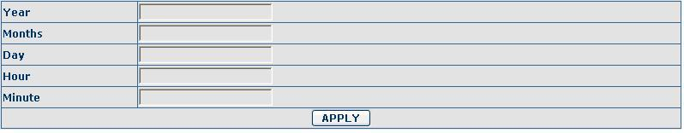
Notice: You need specify the above all items.

4.3.3. VOIP

4.3.3.1. SIP Config
Set your SIP server in the following interface.

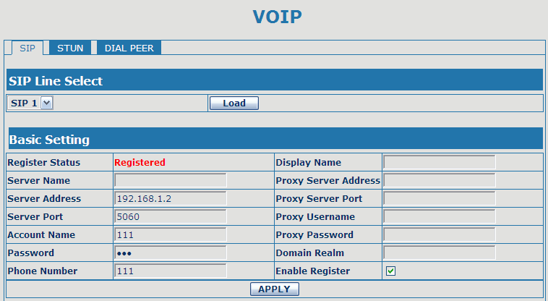

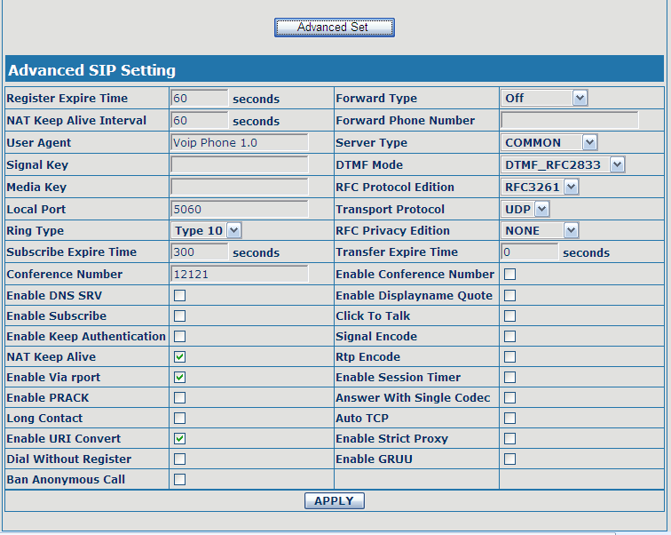

SIP Config
Field name | explanation
Choose line to set info about SIP, there are 2 lines to choose. You can switch by 【Load】 button.
Register Status |  | Shows if the phone has been registered the SIP server or not; or so, show Unapplied;
Server Name |  | Set the server name.
Server Address |  | Input your SIP server address.
Server Port |  | Set your SIP server port.
Account Name |  | Input your SIP register account name.
Password |  | Input your SIP register password.
Phone Number |  | Input the phone number assigned by your VoIP service provider. Phone will not register if there is no phone number configured.
Display Name |  | Set the display name.
Proxy Server Address |  | Set proxy server IP address（Usually, Register SIP Server configuration is the same as Proxy SIP Server. But if your VoIP service provider give different configurations between Register SIP Server and Proxy SIP Server, you need make different settings.）
Proxy Server Port |  | Set your Proxy SIP server port.
Proxy Username |  | Input your Proxy SIP server account.
Proxy Password |  | Input your Proxy SIP server password.
Domain Realm |  | Set the sip domain if needed, otherwise this VoIP phone will use the Register server address as sip domain automatically. (Usually it is same with registered server and proxy server IP address).
Enable Register |  | Start to register or not by selecting it or not.
Register Expire Time |  | Set expire time of SIP server register, default is 60 seconds. If the register time of the server requested is longer or shorter than the expire time set, the phone will change automatically the time into the time recommended by the server, and register again.
NAT Keep Alive Interval |  | Set examining interval of the server, default is 60 seconds
User Agent |  | Set the user agent if have, the default is VoIP Phone 1.0
Signal Key |  | Set the key for signal encryption
Media Key |  | Set the key for RTP encryption
Local port |  | Set sip port of each line
Ring type |  | Set ring type of each line
Subscribe Expire Time |  | Set the interval of Subscribe.
Conference Number |  | Set the server conference number to jion the the room
Enable DNS SRV |  | Support DNS looking up with _sip.udp mode
Enable Subscribe |  | Enable Subscribe.
Enable Keep Authentication |  | Enable/Disable Keep Authentication.
NAT Keep Alive |  | Enable/Disable keeps NAT of SIP alive.  If some server refuse to register with too short interval time, and has no packets sending to device in private network to keep NAT alive, user could set this function ON. It need set the keep alive interval time less than the NAT server’s.
Enable Via rport |  | Enable/Disable system to support RFC3581. Via rport is special way to realize SIP NAT.
Enable PRACK |  | Enable or disable SIP PRACK function, suggest use the default config.
Long Contact |  | Set more parameters in contact field; connection with SEM server
Enable URI Convert |  | Convert # to %23 when send the URI.
Dial Without Register |  | Set call out by proxy without registration;
Ban Anonymous Call |  | Set to ban Anonymous Call;
Forward Type |  | Select call forward mode, the default is Off  - Off：Close down calling forward  - Busy：If the phone is busy, incoming calls will be forwarded to the appointed phone.  - No answer： If there is no answer, incoming calls will be forwarded to the appointed phone.  - Always：Incoming calls will be forwarded to the appoint phone directly.  The phone will Prompt the incoming while doing forward.
Forward Phone Number |  | Appoint your forward phone number.
Server Type |  | Select the special type of server which is encrypted, or has some unique requirements or call flows.
DTMF Mode |  | Select DTMF sending mode, there are three modes:  - DTMF_RELAY  - DTMF_RFC2833  - DTMF_SIP_INFO  Different VoIP Service providers may provide different modes.
RFC Protocol Edition |  | Select SIP protocol version to adapt for the SIP server which uses the same version as you select. For example, if the server is CISCO5300, you need to change to RFC2543, else phone may not cancel call normally. System uses RFC3261 as default.
Transport Protocol |  | Set transport protocols, TCP or UDP;
RFC Privacy Edition |  | Set Anonymous call out safely; Support RFC3323and RFC3325;
Transfer Expire Time |  | The phone send bye and end the call as soon as hang up.
Enable Conference Number |  | Enable/Disable conference
Enable Displayname Quote |  | Set to make quotation mark to displayname as the phone sends out signal, in order to be compatible with server.
Click to Talk |  | Set click to Talk ( need practical software support).
Signal Encode |  | Enable/Disable Signal Encrypt.
RTP Encode |  | Enable/Disable RTP Encrypt.
Enable Session Timer |  | Set Enable/Disable Session Timer, whether support RFC4028.It will refresh the SIP sessions.
Answer With Single Codec |  | Enable/Disable the function when call is incoming, phone replies SIP message with just one codec which phone supports.
Auto TCP |  | Set to use automatically TCP protocol to guarantee usability of transport as message is above 1300 byte
Enable Strict Proxy |  | Support the special SIP server-when phone recieves the patckets sent from server， phone will use the source IP address, not the address in via field.
Enable GRUU |  | Set to support GRUU

4.3.3.2. Stun Config
In this web page, you can config SIP STUN.
STUN:
By STUN server, the phone in private network could know the type of NAT and the NAT mapping IP and port of SIP. The phone might register itself to SIP server with global IP and port to realize the device both calling and being called in private network.

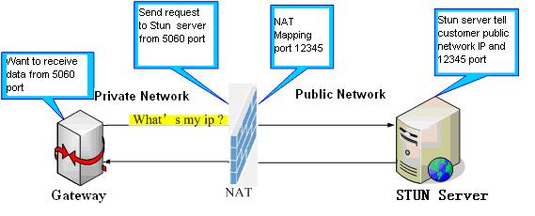

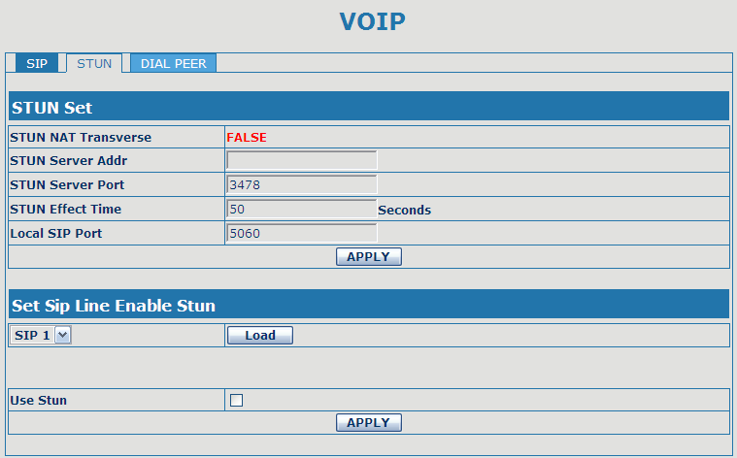

STUN
Field name | explanation
STUN NAT Transverse | Shows STUN NAT Transverse estimation, true means STUN can penetrate NAT, while False means not.
STUN Server Addr | Set your SIP STUN Server IP address
STUN Server Port | Set your SIP STUN Server Port
STUN Effect Time | Set STUN Effective Time. If NAT server finds that a NAT mapping is idle after time out, it will release the mapping and the system need send a STUN packet to keep the mapping effective and alive.
Local SIP Port | Set the SIP port.
Choose line to set info about SIP, There are 2 lines to choose. You can switch by 【Load】 button.
Use Stun | Enable/Disable SIP STUN.
Notice: SIP STUN is used to realize SIP penetration to NAT. If your phone configures STUN Server IP and Port (default is 3478), and enable SIP Stun, you can use the ordinary SIP Server to realize penetration to NAT.

4.3.3.3. DIAL PEER setting
This functionality offers you more flexible dial rule, you can refer to the following content to know how to use this dial rule. When you want to dial an IP address, the entry of IP addresses is very cumbersome, but by this functionality, you can set number 156 to replace 192.168.1.119 here.
When you want to dial a long distance call to Beijing, you need dial an area code 010 before local phone number, but you can also dial number 1 instead of 010 after we make a setting according to this dial rule. For example, you want to dial 01062213123, but you need dial only 162213123 to realize your long distance call after you make this setting.
To save the memory and avoid abundant input of user,add the follow fuctions:
1、x Match any single digit that is dialed.
If user makes the above configuration, after user dials 11 digit numbers started with 13, the phone will send out 0 plus the dialed numbers automatically.

2、[] Specifies a range that will match digit. It may be a range, a list of ranges separated by commas, or a list of digits.

If user makes the above configuration, after user dials 11 digit numbers started with from 135 to 139, the phone will send out 0 plus the dialed numbers automatically.

Use this phone you can realize dialing out via different lines without switch in web interface.

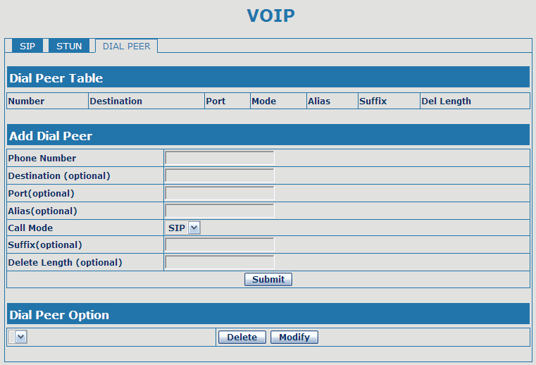

DIAL PEER
Field name | explanation
Phone number | There are two types of matching conditions: one is full matching, the other is prefix matching. In the Full matching, you need input your desired phone number in this blank, and then you need dial the phone number to realize calling to what the phone number is mapped. In the prefix matching, you need input your desired prefix number and T; then dial the prefix and a phone number to realize calling to what your prefix number is mapped. The prefix number supports at most 30 digits
Destination | Set Destination address. This is optional config item. If you want to set peer to peer call, please input destination IP address or domain name. If you want to use this dial rule in SIP2 line, you need input 255.255.255.255 or 0.0.0.2 in it.
Port | Set the Signal port, the default is 5060 for SIP.
Alias | Set alias. This is optional config item. If you don’t set Alias, it will show no alias.
Note: There are four types of aliases.
1) add: xxx, it means that you need dial xxx in front of phone number, which will reduce dialing number length.
2) all: xxx, it means that xxx will replace some phone number.
3) del: It means that phone will delete the number with length appointed.
4) Rep: It means that phone will replace the number with length and number appointed.
You can refer to the following examples of different alias application to know more how to use different aliases and this dial rule.
Call Mode | Select differenct signal protocol, SIP or IAX2
Suffix | Set suffix, this is optional config item. It will show no suffix if you don’t set it.
Delete Length | Set delete length. This is optional config item. For example: if the delete length is 3, the phone will delete the first 3 digits then send out the rest digits. You can refer to examples of different alias application to know how to set delete length.
Introduction of how to set up dial-peer to implement switch between multi- SIP lines
9T mapping: If you have registered a SIP1 server and set dial-peer according to the above table，all calls will be sent via SIP1 server when you press the numeric key “9” in front of dialing destination phone numbers.
8T mapping: If you have registered a Private SIP2 server and set dial-peer according to the above table，all calls will be sent via SIP2 server when you press the numeric key “8” in front of dialing destination phone numbers.
the rule of 2T means user need to dial the number with prefix 2 if he want to dial via IAX2 server
Examples of different alias application
Set by web | explanation | example
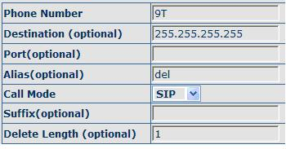 | You need set phone number, Destination, Alias and Delete Length.  Phone number is XXXT, Destination is 255.255.255.255 and Alias is del.  This means any phone No. that starts with your set phone number will be sent via SIP2 line after the first several digits of your dialed phone number are deleted according to delete length. | If you dial “93333”, the SIP2 server will receive “3333”
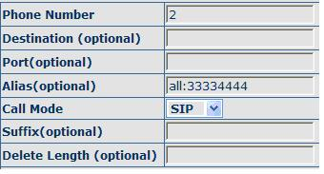 | This setting will realize speed dial function, after you dialing the numeric key “2”, the number after all will be sent out. | When you dial “2”, the SIP1 server will receive 33334444
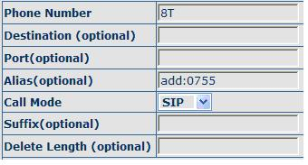 | The phone will automatically send out alias number adding your dialed number, if your dialed number starts with your set phone number. | When you dial “8309“, the SIP1 server will receive “07558309”
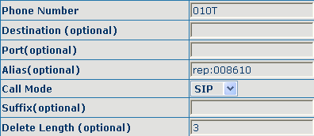 | You need set Phone Number, Alias and Delete Length. Phone number is XXXT and Alias is Rep:xxx  If your dialed phone number starts with your set phone number, the first digits same as your set phone number will be replaced by the alias number specified and New phone number will be send out. | When you dial “0106228”, the SIP1 server will receive “0086106228”
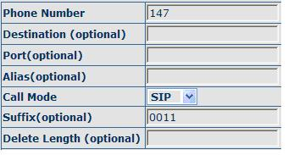 | If your dialed phone number starts with your set phone number. The phone will send out your dialed phone number adding suffix number. | When you dial “147”, the SIP1 server will receive “1470011”

4.3.4. Phone

4.3.4.1. DSP Config
In this page, you can configure voice codec, input/output volume and so on.

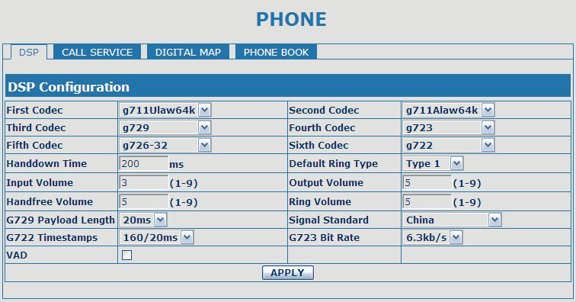

DSP Configuration
Field name | explanation
First Codec | The fist preferential DSP codec: G.711A/u, G.722, G.723, G.729, G.726
Second Codec | The second preferential DSP codec: G.711A/u, G.722, G.723, G.729,G.726
Third Codec | The third preferential DSP codec: G.711A/u, G.722, G.723, G.729,G.726
Forth Codec | The forth preferential DSP codec: G.711A/u, G.722, G.723, G.729,g.726
Fifth Codec | The fifth preferential DSP codec: G.711A/u, G.722, G.723, G.729, G.726
Sixth Codec | The sixth preferential DSP codec: G.711A/u, G.722, G.723, G.729, G.726
Input Volume | Specify Input (MIC) Volume grade.；
Handfree Volume | Specify Handfree Volume grade
G729 Payload Length | Set G729 Payload Length
Handdown Time | Specify the least reflection time of Handdown, the default is 200ms.
Output Volume | Specify Output (receiver) Volume grade.
Ring Volume | Specify Ring Volume grade
G722 Timestamps | 160/20ms or 320/20ms is available
G723 Bit Rate | 5.3kb/s or 6.3kb/s is available
Default Ring Type | Set up the ring by default
Signal Standard | Select Signal Standard.
VAD | Select it or not to enable or disable VAD. If enable VAD, G729 Payload length could not be set over 20ms.

4.3.4.2. Call Service
In this web page, you can configure Hotline, Call Transfer, Call Waiting, 3 Ways Call, Black List, white list Limit List and so on.

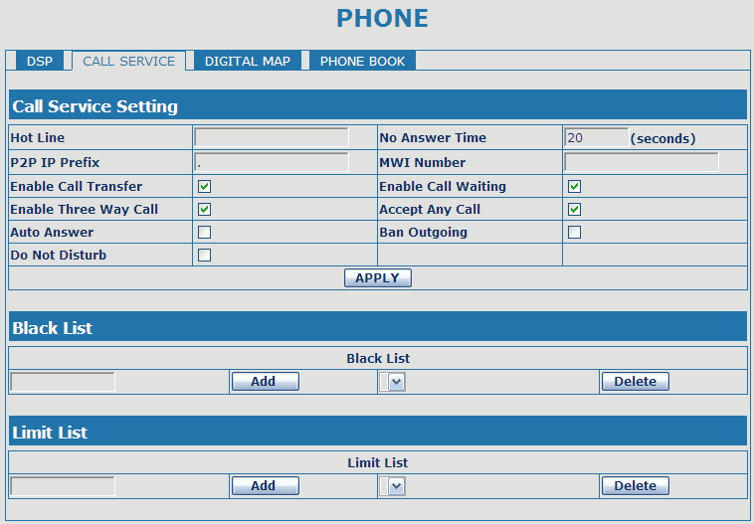

Call Service
Field name | explanation
Hotline | Specify Hotline number. If you set the number, you can not dial any other numbers.
No Answer Time | Specify No Answer Time
P2P IP Prefix | Set Prefix in peer to peer IP call. For example: what you want to dial is 192.168.1.119, If you define P2P IP Prefix as 192.168.1., you dial only #119 to reach 192.168.1.119. Default is “.”. If there is no “.” Set, it means to disable dialing IP.
MWI Number | Set the number to listen voice mail in server.
Enable Call Transfer | Enable Call Transfer by selecting it.
Enable Call Waiting | Enable Call Waiting by selecting it.
Enable Three Way Call | Enable Three Way Call
Accept Any Call | If select it, the phone will accept the call even if the called number is not belong to the phone.
Auto Answer | If select it, the phone will auto answer when there is an incoming call.
Ban Outgoing | If you select Ban Outgoing to enable it, and you can not dial out any number.
Do Not Disturb | Select NO Disturb, the phone will reject any incoming call, the callers will be reminded by busy, but any outgoing call from the phone will work well.
Black List | Set Add/Delete Black list. If user does not want to answer some phone calls, add these phone numbers to the Black List, and these calls will be rejected.  x and . are wildcard. x means matching any single digit. for example, 4xxx expresses any number with prefix 4 which length is 4 will be forbidden to dialed out  DOT (.) means matching any arbitrary number digit. for example, 6. expresses any number with prefix 6 will be forbidden to dialed out.  if user wants to allow a number or a series of number incoming, he may add the number(s) to the list as the white list rule. the configuration rule is -number, for example, -123456, or -1234xx  Means any incoming number is forbidden except for 4119  Note: End with DOT (.) when set up the white list
Limit List | Set Add/Delete Limit List. Please input the prefix of those phone numbers which you forbid the phone to dial out. For example, if you want to forbid those phones of 001 as prefix to be dialed out, you need input 001 in the blank of limit list, and then you can not dial out any phone number whose prefix is 001.  x and . are wildcard. x means matching any single digit. for example, 4xxx expresses any number with prefix 4 which length is 4 will be forbidden to dialed out  . means matching any arbitrary number digit. for example, 6. expresses any number with prefix 6 will be forbidden to dialed out.
Notice: Black List and Limit List can record at most10 items respectively.

4.3.4.3. Digital Map Configuration
This phone supports 4 dial modes:
1). End with “#”: dial your desired number, and then press #.
2). Fixed Length: the phone will intersect the number according to your specified length.
3). Time Out: After you stop dialing and waiting time out, system will send the number collected.
4). User defined: you can customize digital map rules to make dialing more flexible. It is realized by defining the prefix of phone number and number length of dialing.

In order to keep some users' secondary dialing manner when dialing the external line with pbx, phone can be added a special rule to realize it. so user can dial a number as external line prefix and get the secondary dial tone to keep dial the external number. after finishing dialing, phone will send the prefix and external number totaly to ther server.
for example, there is a rule 9,xxxxxxxx in the digital map table. after dialing 9, phone will send the secondary dial tone, user may keep going dialing. after finished, phone will call the number which starts with 9, actually the number sent out is 9-digit with 9.

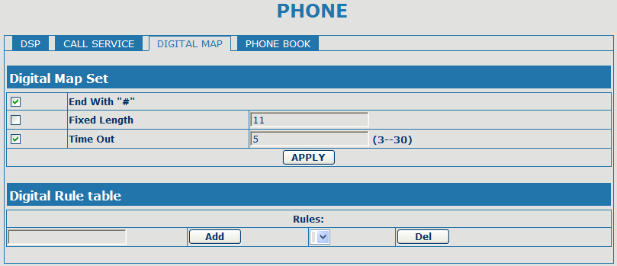

Digital Map Configuration
Field name | explanation
End with "#" | Set Enable/Disable the phone ended with “#” dial.
Fixed Length | Specify the Fixed Length of phone ending with.
Time out | Set the timeout of the last dial digit. The call will be sent after timeout.
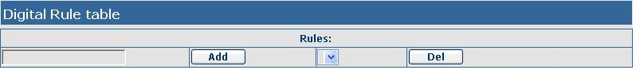
Below is user-defined digital map rule:
[] Specifies a range that will match digit. May be a range, a list of ranges separated by commas, or a list of digits.
x Match any single digit that is dialed.
. Match any arbitrary number of digits including none.
Tn Indicates an additional time out period before digits are sent of n seconds in length. n is mandatory and can have a value of 0 to 9 seconds. Tn must be the last 2 characters of a dial plan. If Tn is not specified it is assumed to be T0 by default on all dial plans.
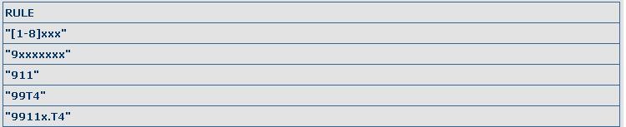[1-8]xxx: Cause extensions 1000-8999 to be dialed immediately
9xxxxxxx: Cause 8 digit numbers started with 9 to be dialed immediately
911: Cause 911 to be dialed immediately after it is entered.
99T4: Cause 99 to be dialed after 4 seconds.
9911x.T4:Cause any number started with 9911 to be dialed 4 seconds after dialing ceases.
Notice: End with “#”, Fixed Length, Time out and Digital Map Table can be used simultaneously, System will stop dialing and send number according to your set rules.

4.3.4.4. Phone Book
You can input the name, phone number and select ring type for each name here.

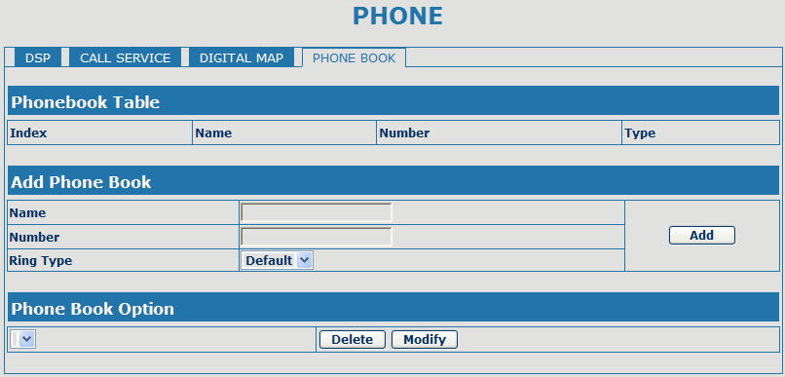

Phone Book
Field name | explanation
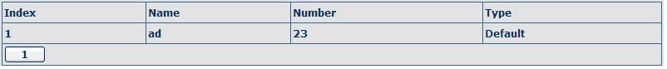
Shows the detail of current phonebook.
Name | Shows the name corresponding to the phone number
Number | Shows the phone number
Ring Type | Shows the ring type of the incoming call.
Click “Modify” to change the selected information and click the “Delete” to delete the selected record.
Notice: the maximum capability of the phonebook is 500 items

4.3.5. Maintenance

4.3.5.1. Auto Provision

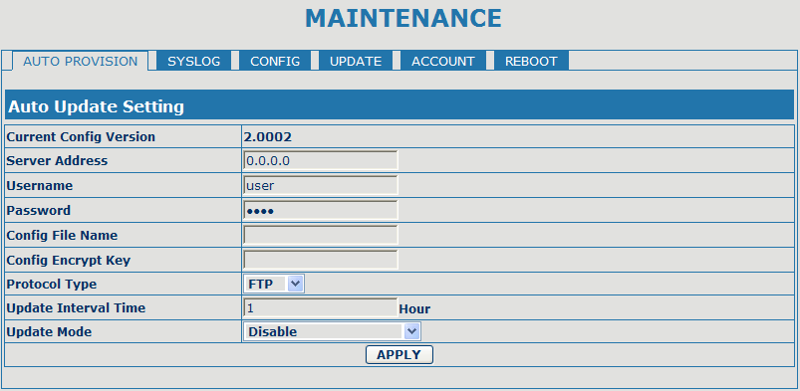
Auto Provision
Field name | explanation
Current Config Version | Show the current config file’s version.
Server Address | Set FTP/TFTP/HTTP server IP address for auto update. The address can be IP address or Domain name with subdirectory.
Username | Set FTP server Username. System will use anonymous if username keep blank.
Password | Set FTP server Password.
Config File Name | Set configuration file’s name which need to update. System will use MAC as config file name if config file name keep blank. For example, 000102030405.。
Config Encrypt Key | Input the Encrypt Key, if the configuration file is encrypted.
Protocol Type | Select the Protocol type FTP、TFTP or HTTP.
Update Interval Time | Set update interval time, unit is hour.
Update Mode | Different update modes:  1. Disable: means no update  2. Update after reboot: means update after reboot.  3. Update at time interval: means periodic update.

4.3.5.2. Syslog Config
Syslog is a protocol which is used to record the log messages with client/server mechanism. Syslog server receives the messages from clients, and classifies them based on priority and type. Then these messages will be written into log by some rules which administrator can configure. This is a better way for log management.
8 levels in debug information:
Level 0---emergency: This is highest default debug info level. You system can not work.
Level 1---alert: Your system has deadly problem.
Level 2---critical: Your system has serious problem.
Level 3---error: The error will affect your system working.
Level 4---warning: There are some potential dangers. But your system can work.
Level 5---notice: Your system works well in special condition, but you need to check its working environment and parameter.
Level 6---info: the daily debugging info.
Level 7---debug: the lowest debug info. Professional debugging info from R&D person.
At present, the lowest level of debug information send to Syslog is info, debug level only can be displayed on telnet.

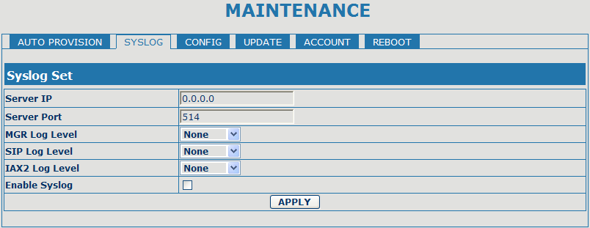

Syslog Configuration
Field name | explanation
Server IP | Set Syslog server IP address.
Server Port | Set Syslog server port.
MGR Log Level | Set the level of MGR log.
SIP Log Level | Set the level of SIP log.
IAX2 Log Level | Set the level of IAX2 log.
Enable Syslog | Select it or not to enable or disable syslog.

4.3.5.3. Config Setting

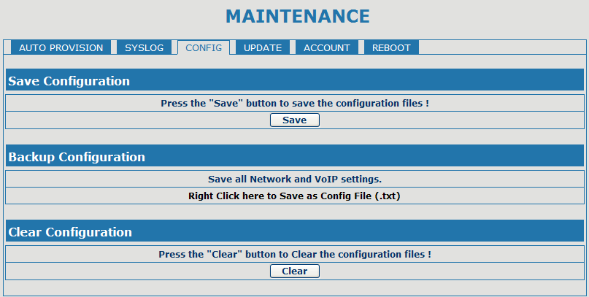
Config Setting
Field name | explanation
Save Config | you can save all changes of configurations. Click the Save button, all changes of configuration will be saved, and be effective immediately. .
Backup Config | Right clicks on “Right click here…” and select “Save Target As….” then you will save the config file in .txt format
Clear Config | user can restore factory default configuration and reboot the phone.  If you login as Admin, the phone will reset all configurations and restore factory default; if you login as Guest, the phone will reset all configurations except for VoIP accounts (SIP1-2 and IAX2) and version number.

4.3.5.4. Update
You can update your configuration with your config file in this web page.
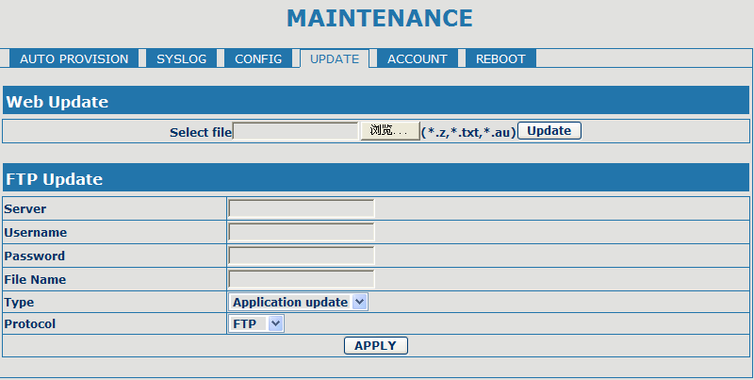

Update
Field name | explanation
Web Update | Click the browse button, find out the config file saved before or provided by manufacturer, download it to the phone directly, press “Update” to save. You can also update downloaded update file, logo picture, ring, mmiset file by web.
Server | Set the FTP/TFTP server address for download/upload. The address can be IP address or Domain name with subdirectory.
Username | Set the FTP server Username for download/upload.
Password | Set the FTP server password for download/upload.
File name | Set the name of update file or config file. The default name is the MAC of the phone, such as 000102030405.
Notice: You can modify the exported config file. And you can also download config file which includes several modules that need to be imported. For example, you can download a config file just keep with SIP module. After reboot, other modules of system still use previous setting and are not lost.
Type | Action type that system want to execute：  1. Application update: download system update file  2. Config file export: Upload the config file to FTP/TFTP server, name and save it.  3. Config fie import: Download the config file to phone from FTP/TFTP server. The configuration will be effective after the phone is reset.
Protocol | Select FTP/TFTP server

4.3.5.5. Account Config

You can add or delete user account, and change the authority of each user account in this web page

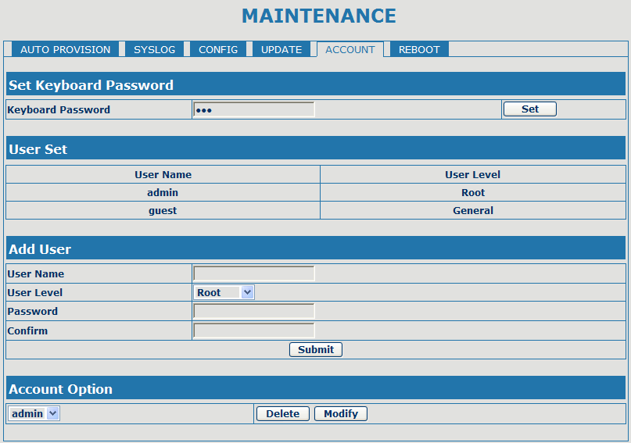

Account Configuration
Field name | explanation
Keyboard Password | Set the password for entering the setting menu of the phone by the phone‘s key board. The password is digit.
This table shows the current user existed.
User Name | Set account user name.
User Level | Set user level, Root user has the right to modify configuration, General can only read.
Password | Set the password.
Confirm | Confirm the password.
Select the account and click the Modify to modify the selected account, and click the Delete to delete the selected account.
General user only can add the user whose level is General.

4.3.5.6. Reboot

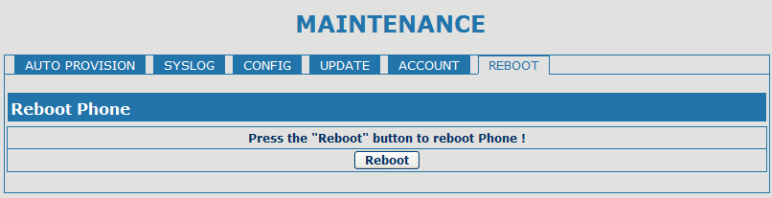
If you modified some configurations which need the phone’s reboot to be effective, you need click the Reboot, then the phone will reboot immediately.

Notice: Before reboot, you need confirm that you have saved all configurations..

4.3.6. Security

4.3.6.1. MMI Filter

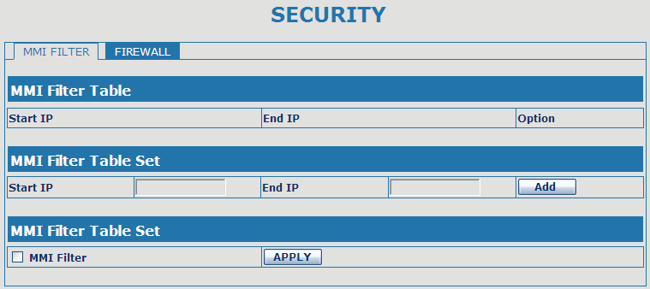

MMI Filter
User could make some device own IP, which is pre-specified, access to the MMI of the phone to config and manage the phone.
Field name | explanation
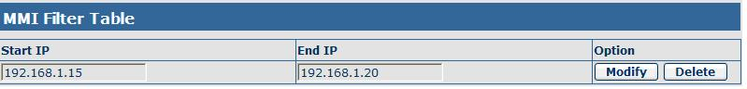
MMI Fileter IP Table list:
Add or delete the IP address segments that access to the phone.
Set initial IP address in the Start IP column, Set end IP address in the End IP column, and click Add to add this IP segment. You can also click Delete to delete the selected IP segment.
MMI Filter | Select it or not to enable or disable MMI Filter. Click Apply to make it effective.
Notice: Do not set your visiting IP outside the MMI filter range, otherwise, you can not logon through the web.

4.3.6.2. Firewall

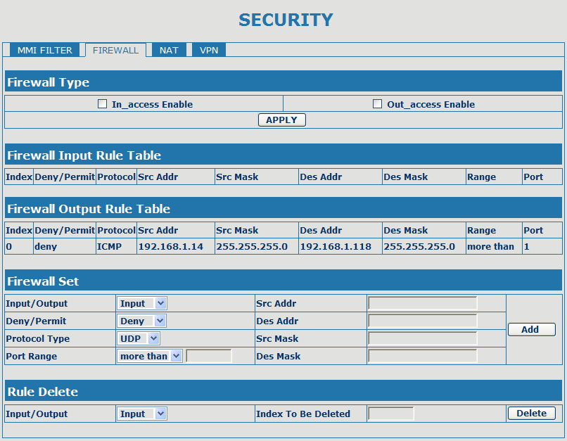

Firewall Configuration
In this web interface, you can set up firewall to prevent unauthorized Internet users from accessing private networks connected to the Internet (input rule), or prevent unauthorized private network devices from accessing the Internet (output rule).
Firewall supports two types of rules: input_access rule and output_access rule. Each type supports at most 10 items.
Through this web page, you could set up and enable/disable firewall with input/output rules. System could prevent unauthorized access, or access other networks set in rules for security. Firewall, is also called access list, is a simple implementation of a Cisco-like access list (firewall). It supports two access lists: one for filtering input packets, and the other for filtering output packets. Each kind of list could be added 10 items.
We will give you an instance for your reference.
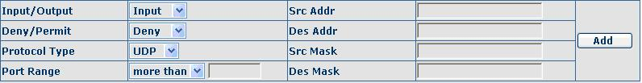
Field name | explanation
In_access enable | Select it to Enable in_ access rule
out_access enable | Select it to Enable out_ access rule
Input/Output | Specify current adding rule by selecting input rule or output rule.
Deny/Permit | Specify current adding rule by selecting Deny rule or Permit rule.
Protocol Type | Filter protocol type. You can select TCP, UDP, ICMP, or IP.
Port Range | Set the filter Port range
Src Addr | Set source address. It can be single IP address, network address, complete address 0.0.0.0, or network address similar to *.*.*.0
Des Addr | Set the destination address. It can be IP address, network address, complete address 0.0.0.0, or network address similar to *.*.*.*
Src Mask | Set the source address’ mask. For example, 255.255.255.255 means just point to one host; 255.255.255.0 means point to a network which network ID is C type.
Des Mask | Set the destination address’ mask. For example, 255.255.255.255 means just point to one host; 255.255.255.0 means point to a network which network ID is C type.
Click the Add button if you want to add a new output rule.
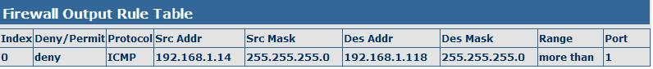
Then enable out_access, and click the Apply button.
So when devices execute to ping 192.168.1.118, system will deny the request to send icmp request to 192.168.1.118 for the out_access rule. But if devices ping other devices which network ID is 192.168.1.0, it will be normal.
Click the Delete button to delete the selected rule.

4.3.7. Logout

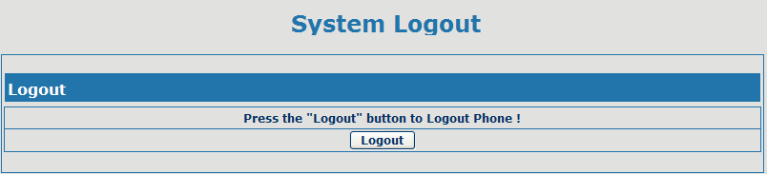

Click Logout，and you will exit web page. If you want to enter it next time, you need input user name and password again.

4.4. Settings via phone’s keyboard.

4.4.1. How to set via the phone’s keyboard.
Press Menu, Up/Down, Enter and exit key to browse, select, and cancel
- Use the Up/Down key to browse the menu and submenu
- Use the ENTER key to enter into submenu and confirm your operation, the EXIT key can be used to back and cancel operation.

4.4.2. Phone menu
Phone main menu:

5. Appendix

5.1. Specification

5.1.1. Device specification
Item |  | this VoIP Phone
Adapter(Input/Output) |  | Input:100-240VAC 50～60Hz Output:5V/1A
Port | WAN | 10/100Base- T RJ-45 for LAN, Auto MDIX
Port | LAN | 10/100Base- T RJ-45 for PC, Auto MDIX
Power Consumption |  | Idle:1.5W/Active:1.8W
LCD size |  | 74 x 28mm
Operation Temperature |  | 0～40℃
Relative Humidity |  | 10～65%
Main Chipset |  | Broadcom
SDRAM |  | 64Mbits
Flash |  | 8Mbits
Size（W x H x D） |  | 11.6×8×3 in.(295×205×75mm)
Weight |  | 2.07lb.(0.94kg)

5.1.2. Voice Features
- Support 2 lines SIP, SIP 2.0 (RFC3261)
- Codec：G.711A/u，G.7231 high/low，G.729, G.722,G.726
- Echo cancellation： Support G.168 and hand-free can support 96ms
- Support VAD，CNG
- NAT transverse: support STUN
- Supports full duplex.
- SIP support SIP domain，SIP authentication（none，basic， MD5），DNS name of server, peer to peer
- SIP support 2 servers, user can through each server to calling in and out
- DTMF:SIP info，DTMF Relay，RFC2833
- SIP application: contain SIP call forward/transfer/holding/waiting/3 way conference/Paging and intercom/ click to dial/pickup/ joincall/redial/unredial.
- Call control features: Flexible dial map, support hotline, empty calling no. reject server, black list for reject, authenticated call, no disturb, caller ID and so on.
- Could dial use private server automatically when public server unregistered while private server is resgistered successfully
- Support phonebook 500 records, incoming calls / outgoing calls / missing calls. Each supports 100 records
- Support MWI
- support conference call in server
- Phonebook supports VCard standard
- Support 12/24 time format.
- Support daylight saving time
- Support path, gruu
- Support SIP Privacy.

5.1.3. Network Features
- WAN/LAN: support Bridge mode.
- Support PPPoE for xDSL
- support VLAN
- Support Stun penetration
- Support DHCP get IP on WAN port
- Qos supports Diffserv.
- support network tools: contain ping，trace route，telnet client

5.1.4. Maintenance and Management
- The phone supports post mode, can update firmware by post mode.
- Supports different levels of administration.
- Support Boot Monitor
- Can upgrade firmware through boot monitor
- access with different authority
- support auto provisioning
- Can config through Web, Keypad, Telnet
- Can upgrade firmware and configuration file through HTTP, FTP, TFTP
- Support syslog

5.2. Digit-character map table
Button | Character | Button | Character
 | 1 @ |  | 7 P Q R S p q r s
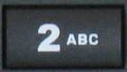 | 2 A B C a b c |  | 8 T U V t u v
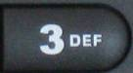 | 3 D E F d e f |  | 9 W X Y Z w x y z
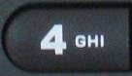 | 4 G H I g h i |  | .
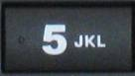 | 5 J K L j k l |  | 0
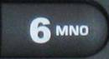 | 6 M N O m n o |  | #

